
CONFERENCE
AGENDA

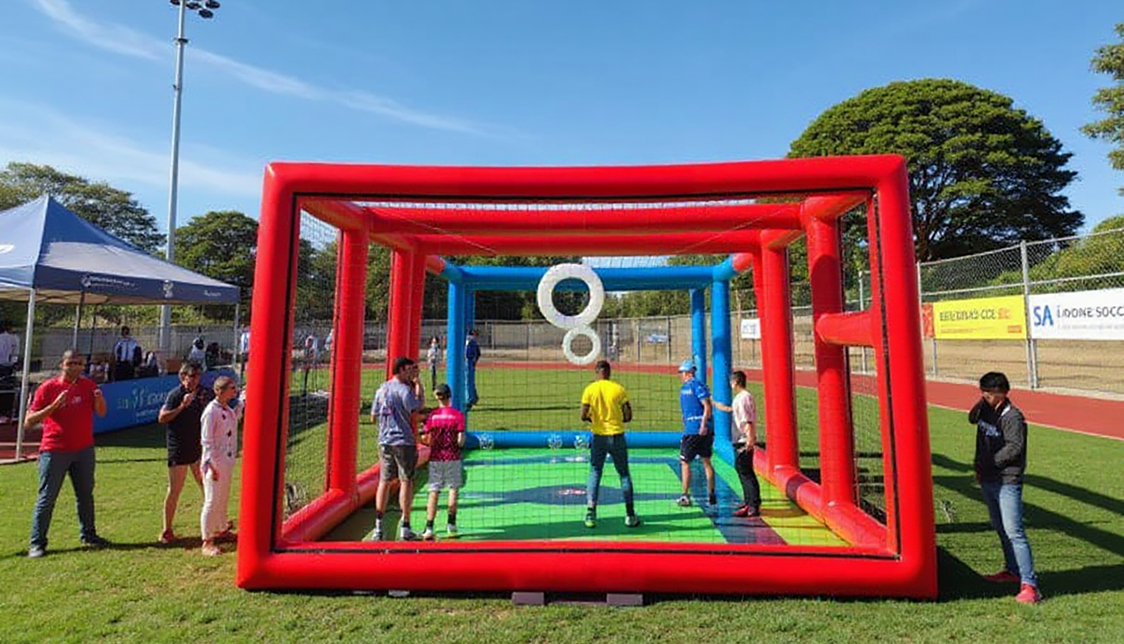

DATE:
30 July 2025
TIME:
09:00 AM – 15:30 PM
VENUE:
The Innovation Hub, Pretoria

SOUTH AFRICA TAKES FLIGHT:
SA DRONE SOCCER LAUNCH

🎟️ Secure Your Spot: SA Drone Soccer Tournament Launch

Join us at the historic launch of South Africa’s first Drone Soccer
Tournament - a fusion of sport, innovation, and inclusive education.

📍 Venue: The Innovation Hub, Pretoria
📅 Date: Wednesday, 30 July 2025
🕘 Time: 09:00 - 13:00
HOW TO REGISTER
Scan the QR code to access the official registration form on our website.
Kindly complete your details to confirm attendance at the SA Drone Soccer Tournament Launch. This ensures streamlined access, event updates, and your place at this milestone celebration of innovation, sport, and STEAM education.

This event brings together schools, TVET colleges, industry leaders,
sponsors, and government in celebration of youth, technology, and
STEAM learning. Expect fast-paced drone matches, keynote speakers,
exciting performances, and networking opportunities.

Whether you're a learner, educator, policymaker, or tech enthusiast
- this launch is for you.
✅ Attendance is free. RSVP to secure your place.
📩 For questions, email us at info@sadronesoccer.com
Time  DRONE SOCCER LAUNCH PROGRAMME | Item | Speaker
09:00 – 09:10 | Opening Remarks: Programme Director | Ms. Gcina Madonsela
09:10 – 09:20 | Welcome Address | Mr. Bangani Mpangalasane,  CEO: The Innovation Hub
09:20 – 09:30 | Background and Purpose of the Event | Ms. Queen Ndlovu  CEO: QP Drone Tech-South African Flying Labs (SAFL)
09:30 – 09:40 | Collaboration is the New Innovation:  Founding Members and Hosts | Ms. Jolene Balakisten  CEO: Drone Labs
09:40 – 09:50 | Vision: Beyond the Launch | Mr. Jack Shilubana  COO: QP Drone Tech-SAFL
9:50 – 10:05 | Telkom : ESD Support | Ms. Mathebe Mhlongo  Manager: Enterprise and Supplier Development, Future Makers
10:05 – 10:20 | Sponsors’ Address: Makwa IT | Ms. Mahlogonolo Masenya  Head of People and Culture
10:20 – 10:35 | Sponsors’ Address: Innovation Hub | Ms. Linah Nematandani  Acting General Manager: Marketing  and Communications
10:35 – 10:40 | CATHSSETA  Message of Support | Ms. Lebohang Mpye  Executive Manager: Learning Programmes
10:40 – 10:45 | African Bank  Message of Support | Ms Stompie Xulu  Stakeholder Relations & Sustainability Manager
10:45– 10:50 | South African Football Association (SAFA)  Message of Support | Mr. Buddha Mathathe  National Executive Member
10:50 – 10:55 | The Department of Women, Youth, and Persons with Disabilities-  Message of Support | Dr Bernice Hlagala
10:55– 11:10 | MEC of Sports, Arts, Culture & Recreation  Message of Support | Mr. Matome Chiloane
11:10 – 11:30 | Keynote Address | Hon. Buti Manamela  Deputy Minister of Higher Education
11:30– 12:00 | Keynote Address | Hon. Gayton McKenzie,  Minister of Sports, Arts & Culture
12:00– 12:10 | Vote of Thanks and Closing  Remarks- | Mr. Leonard Balakisten  Chairman of Drone Labs &  SAFL-Special Advisor
12:10 – 13:00 | Drone Competition Facilitator  (TVET Colleges) | Mr. Preneshen Moodley  Drones Labs Project Manager
13:00 – 13:10 | Awards & Prize-giving | Ms. Sharon Maasdorp & Ms. Mathebe Mhlongo  Makwa-IT and Telkom
13:10– 14:00 | Lunch, Networking and Entertainment
OUR
SPEAKERS
10:00 – 11:30 | Insert the conference program name one here
11:30 – 12:00 | Insert the conference program name two here
12:00 – 13:30 | Insert the conference program name three here
13:30 – 14:00 | Insert the conference program name four here
14:00 – 15:30 | Insert the conference program name five here
15:30 – 16:00 | Insert the conference program name six here

CONFERENCE DAY 3
ABOUT SPONSORSHIP:
To become our event sponsorship,
Please visit: www.your-events.com
MORE INFORMATION:
Website: www.website_here.com
Instagram: events_account_here
CONTACT PERSON:
Ariella (+88 12 345 6789 108)
Therehope (+88 12 345 6789 109)

